

**INTRODUCTION TO ROBOTICS**

**(MTS -417)**

**DE-44 Mechatronics Syndicate– C**

**Lab Report 3**

**Name of members:**

**NC** M. Ahmed Hussain Babar (**427781)**

**PC** Abdul Haseeb Zahid (**432219)**

**PC** Rehan Shahid (**432283)**

**Submitted to**: LE Hamza Sohail

**Task 1: Velocity Control**

|  |
| --- |
| **Lua Script:** |
| function sysCall_init()  sim = require('sim')  prismaticJoint = sim.getObjectHandle('Prismatic_joint')  targetVelocity = 0.1  -- do some initialization here  end  function sysCall_actuation()  sim.setJointTargetVelocity(prismaticJoint, targetVelocity)  end  function sysCall_sensing()  -- put your sensing code here  end  function sysCall_cleanup()  -- do some clean-up here  end  -- See the user manual or the available code snippets for additional callback functions and details |

**Simulation Snippet:**

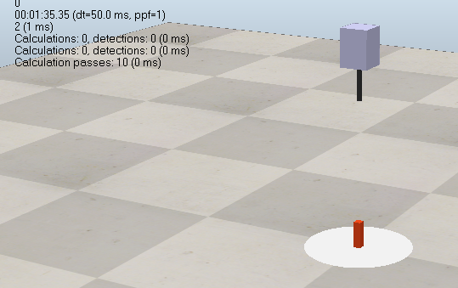

Figure 1

**Task 2: Position Control**

|  |
| --- |
| **Lua Script:** |
| function sysCall_init()  sim = require('sim')  prismaticJoint = sim.getObjectHandle('Prismatic_joint')  targetPosition = 0.2  -- do some initialization here  end  function sysCall_actuation()  sim.setJointTargetPosition(prismaticJoint, targetPosition)  end  function sysCall_sensing()  -- put your sensing code here  end  function sysCall_cleanup()  -- do some clean-up here  end  -- See the user manual or the available code snippets for additional callback functions and details |

**Simulation Snippet:**

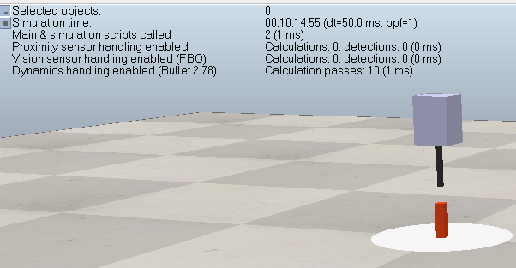

Figure 2

**Results:**

* **The prismatic joint moved linearly along its defined axis under both velocity and position control.**
* **In velocity control mode, the cuboid moved at a steady constant speed according to the target velocity value.**
* **In position control mode, the cuboid smoothly reached the specified target position and then stopped precisely.**
* **Changing the target values directly affected motion behavior — higher velocity made the cuboid move faster, while higher position values increased the displacement.**
* **The control response was stable and linear, with no oscillations or abrupt motion.**

**Discussion**:

* The experiment confirmed that the same control functions used for revolute joints can be applied to prismatic joints, with the difference being **linear translation** instead of **rotation**.
* **Velocity control** is suitable for continuous linear movement, while **position control** provides accurate displacement control for specific tasks.
* This behavior is similar to real-world **linear actuators** used in robots for precise pushing or sliding motions.
* The simulation demonstrated how **joint control parameters** (velocity, position) directly influence motion performance and system stability.

**Conclusion**:

The lab successfully demonstrated velocity and position control of a prismatic joint connected to a cuboid. Velocity control achieved consistent linear motion, while position control accurately reached target positions. The setup and script can be extended for more complex robotic tasks.